**GUJARAT TECHNOLOGICAL UNIVERSITY**

Chandkheda, Ahmedabad

Affiliated



**MADHUBEN AND BHANUBHAI PATEL INSTITUTE OF ENGINEERING FOR STUDIES AND RESEARCH IN COMPUTER AND COMMUNICATION TECHNOLOGY, NEW V. V. NAGAR**

A Report On-

**SHADYANTRA-THE MIND GAME**

Under subject of

**Project – II (181601)**

B. E. 4th Year, Semester – 8th

(Information Technology Branch)

**GTU Group ID: 46661**

**UDP Project**

**Submitted By:-**

Janiece Pandya (120630116007)

Pooja Patel (120630116025)

**Prof. Hetal Chudasama**

**(Faculty Guide)**

**Prof. Hetal Chudasama**

**Head of the Department**

Academic year 2015-16



***MADHBEN AND BHANUBHI PATEL INSTITUTE OF ENGINEERING FOR STUDIES AND RESEARCH IN COMPUTER AND COMMUNICATION TECHNOLOGY,***

***NEW V. V. NAGAR***

CERTIFICATE

This is to certify that the dissertation entitled **“SHADYANTRA-THE MIND GAME ”** has been carried out by **JANIECE PANDYA & POOJA PATEL** under my guidance in fulfillment of the degree of Bachelor of Engineering in Information Technology 8th Semester of Gujarat Technological University, Ahmedabad during the academic year 2015-16.

Prof. Hetal Chudasama Prof. Hetal Chudasama

**Internal Guide Head of Department**

**TABLE OF CONTENTS**

|  |  |  |
| --- | --- | --- |
|  | Declaration | 5 |
|  | Acknowledgement | 6 |
|  | List of Figures | 7 |
|  | Abstract | 8 |
| 1 | INTRODUCTION  1.1 Problem Summary And Introduction  1.2Aim of the project  1.3 Objective of the project  1.4Problem Specifications  1.4.1 OS fragmentation  1.4.2. Adding AI in our game  1.4.3. Maintaining minimum storage space  1.4.4. Creating game board for different level.  1.5 Literature review  1.6 Material and tools required  1.6.1 Front End Tools: Cocos2d-X,CocoStudio  1.6.2 Development Environment:  JDK, NDK, SDK, Apache ANT, Eclipse with  ADT, Visual Studio 2013 Professional, XCode  1.6.3 Language: C++  1.6.4 Diagram Tools: Microsoft Office Visio 2007  1.6.5 Hardware Requirements 1.6.6 Software Requirements 1.7 Plan of their work | 9 |
| 2 | DESIGN  2.1 Analysis  2.1.1 Project plan  2.2 Design methodology  2.2.1 Class Diagram  2.2.2 Use-Case Diagram  2.2.3 Sequence Diagram  2.3 Implementation Strategy  2.3.1 Implementation Environment  2.3.2 Coding Standards  2.3.3 Security Features  2.4 Canvas  2.4.1 Empathy Summary  2.4.2 AEIOU Summary  2.4.3 Ideation Canvas  2.4.4 Product Development Canvas  2.5 BMC Canvas  2.5.1 Key Partners  2.5.2 Key Activities  2.5.3 Key resources  2.5.4 Value Propositions  2.5.5 Customer Relationships  2.5.6 Customer Segments  2.5.7 Channels  2.5.8 Cost structure  2.5.9 Revenue Streams | 15 |
| 3 | IMPLEMENTATION  3.1 Game Home Page  3.2 3x3 Level1  3.3 3x3 Leve2  3.4 Creation of a mill  3.5 4x4 Level  3.6 5x5 Level | 39 |
| 4 | SUMMARY  4.1 Conclusion  4.2 Study of current system  4.3 Advantages  4.4 Scope of future work  4.4.1 Difficulty Levels in our game  4.4.2 Include time limit in our game  4.4.3 Changing levels abruptly | 44 |
| 5 | REFERENCE | 47 |
|  | Appendix-A Periodic Progress Reports (PPR)  Appendix-B Patent Drafting Exercise (PDE) |  |

**DECLARATION**

We hereby certify that we are the soul authors of this report and that neither any part of this work nor the whole of the work has been submitted for a Degree to any other University or Institution.

We certify that, to the best of our knowledge, our work does not infringe upon anyone’s copyright nor violate any proprietary rights and that any ideas, technologies, quotations or any other material from the work of other people included in our report, published or otherwise, are fully acknowledged in accordance with the standard referencing practices. Furthermore, to the extent that we have included copyright material that surpasses the bounds of fair dealing within the meaning of Indian Copyright Act, We certify that we have obtained a written permission from the copyright owner(s) to include such material(s) in our work and have includes copies of such copyright clearances to our appendix.

We declare that this is true copy of our report, including any final revisions, as approved by our Supervisor.

**Date : 20th April, 2016**

**Place : New Vallabh Vidhyanagar**

Janiece Pandya 120630116007

Pooja Patel 120630116025

**ACKNOWLEDGEMENT**

We take this opportunity with much pleasure to thank all the people who have helped us through the course of our journey towards producing this report.

We sincerely thank our Head of Department as well as our project guide

**Prof. Hetal Chudasama** for her guidance, help and motivation. Apart from the subject of our project, we learnt a lot from her, which we are sure, will be useful to us in different stages of our life. We would like to express our gratitude to her for much help with the project design and methodology, and for review and many helpful comments.

We would like to thank our concerned faculty members for their assistance in finalizing the project problem and useful comments. We would like to thank our other faculty members at **MBICT** for their caring and supportive attitude. We would like to thank all the lab assistants for their assistance and help.

JANIECE PANDYA (120630116007)

POOJA PATEL (120630116025)

**LIST OF FIGURES**

|  |  |  |
| --- | --- | --- |
| FIGURE NO. | NAME OF FIGURE | PAGE NO |
| 1.7 | Work Plan | 6 |
| 2.1 | Software Model | 7 |
| 2.2.1 | Class Diagram | 8 |
| 2.2.2 | Usecase Diagram | 9 |
| 2.2.3 | Sequence Diagram | 10 |
| 2.4.1 | Empathy summary | 11 |
| 2.4.2 | AEIOU summary | 13 |
| 2.4.3 | Ideation Canvas | 15 |
| 2.4.4 | Product Development Canvas | 16 |
| 2.5 | BMC Canvas | 29 |
| 2.5.1 | Key Partners | 30 |
| 2.5.2 | Key Activities | 31 |
| 2.5.3 | Key Resources | 32 |
| 2.5.4 | Value Propositions | 33 |
| 2.5.5 | Customer Relationships | 34 |
| 2.5.6 | Customer Segments | 35 |
| 2.5.7 | Channels | 36 |
| 2.5.8 | Cost Structure | 37 |
| 2.5.9 | Revenue Streams | 38 |
| 3.1 | Game Home Page | 39 |
| 3.2 | 3x3 Level1 | 40 |
| 3.3 | 3x3 Level2 | 41 |
| 3.4 | Creation of Mill | 41 |
| 3.5 | 4x4 Level | 42 |
| 3.5.1 | 5x5 Level | 43 |

**ABSTRACT**

“Shadyantra-The Mind Game” is a multiplayer stratergy board game which is developed from the very famous game of Saurashtra known as “Nav Kankari” or also known as “Nine Men’s Morris” in Roman Empire. This game is played on a board consisting of three concentric squares connected by lines from the middle of each of the inner square's sides to the middle of the corresponding outer square's side. Pebbles are placed on the points where two or more lines meet or intersect, so there are 24 such points. This is a two-player game and each player gets 9 coins(depending on the level) of different colour. The winning point of our game is to create a “Mill” i.e. to form horizontal or vertical lines of three coins/pebbles of same color so as to destroy any one pebble of opponent from any random position on the board.

**CHAPTER 1: INTRODUCTION**

**1.1 PROBLEM SUMMARY AND INTRODUCTION**

The game of Nine Pebbles is played on a board consisting of three concentric squares connected by lines from the middle of each of the inner square's sides to the middle of the corresponding outer square's side.

Pieces are played on the points where two or more lines meet or intersect, so there are 24 playable points. This is a two-player game and each player gets 9 coins of different color.

**1.2AIM OF THE PROJECT**

The basic aim of a player is to make ‘Mills’ - vertical or horizontal lines of three coins of same color.

**1.3 OBJECTIVES OF THE PROJECT**

Every time a “Mill” is achieved, an opponent's piece is removed.

The overall objective is to reduce the number of opponent's coins to 'two' or to block all moves of the opponent thus rendering the opponent unable to play.

**1.4 PROBLEM SPECIFICATION**

1.4.1 OS fragmentation

Mobile device fragmentation is a phenomenon that occurs when some mobile users are running older versions of an operating system, while other users are running newer versions.

1.4.2. Adding AI in our game

With one player as system and other as real player, it becomes more difficult to code the game.

1.4.3. Maintaining minimum storage space

With updated versions of OS and game it is difficult to maintain storage space.

1.4.4. Creating game board for different level.

It is somewhat difficult to create game board for different levels

**1.5 LITERATURE REVIEW**

~ Shadyantra-The Mind Game is a multiplayer game which is basically adopted from the very famous Kathiawadi game “Nav-Kankari”.

~ We have referred various games on Google Play Store as a part of our literature review.

~This game resembles many games on Google Play Store but we have added many more features to it to make it more interesting.

~ Features:-

* Asynchronous Multiplayer(2) Game.
* Social SDK Connectivity.
* App Push Notifications.
* Sending Moves/Challenges to other Users.
* Increasing difficulty levels.

# 1.6 MATERIAL AND TOOLS REQUIRED

# 1.6.1 Front End Tools:

**1. Cocos2d-X:**

Cocos2d-X is a suite of open-source, cross-platform 2D game engine, which is useful in

game-development, Application Development and other cross-platform GUI based

interactive programs. We will be using the V3.8.1 in our project.

The target platforms that can be intended by using cocos2D-X are iOS, Android, Tizen,

Windows 8, Windows phone 8, Linux and Mac OS.

The languages that can be used with cocos2d-X are: C++, Lua and JavaScript.

The various IDEs that can be used with Cocos2d-X are Eclipse and Android Studio

(android), XCode (Mac OS), Visual Studio(windows),etc.

**2. CocoStudio:**

CocoStudio is a professional game development tool based on Cocos2d-x.

With CocoStudio, developers can create game resources quickly and simplify most of the tedious development work with 4 editors: UI Editor, Animation Editor, Scene Editor and Data Editor.

These 4 editors cover the core process of game development by dealing with animation

resources, UI interface, gaming scene and gaming data. Also, each of them has been

specifically designed for the best of the corresponding role in the development team and

therefore can be used to complete the work with more efficiency.

**1.6.2 Development Environment**

a) JDK:

Java Development Kit is a set of tools that are to be installed for any kind of android java development. Version 1.6 or above can be used. JDK includes many components such as applet viewer, apt, java, javac, etc.

b) Android SDK:

Android Software Development Kit consists of comprehensible set of development tools

that includes debugger, libraries, emulator, documentation, sample code and tutorials.

Android SDK is needed to be installed in the PC before starting with any IDE that deals with android development.

c) Android NDK:

Native Development Kit is a tool-set that helps to implement some parts of the code in the native languages like C and C++.

d) Apache Ant:

Apache Ant is command line tool that can be used to build/compile several code files of a software project. It doesn’t itself compile anything but just automates the sequence of steps required for building the project. For cocos2d-X projects, it is used to automate the compilation and linking of all the code files into the android APK.

e) Eclipse with ADT installed:

Eclipse is an IDE that is used for the development of any android based application.

Whenever we want to use Eclipse for the development of any application related to Android, it needs to have ADT plugin installed within it. ADT stands for Android Development Toolkit, which provides with the set of tools that will be useful to develop any android application. Also, for using Eclipse, JDK and Android SDK must be installed.

f) Visual Studio 2013 Professional Edition:

Visual Studio is again an IDE (uses a modified version of C++), that is useful for the development of any windows-based application. It is used to develop the windows-specific code of the Game.

e) XCode:

XCode is also an IDE that provides all the tools that are needed to develop applications for Mac OS. This IDE can be run only on Mac OS. Hence, a Mac system is required so as to develop the Mac-specific code of the Game.

# 1.6.3 Language :C++

C++ is a statically typed, compiled, general-purpose, case-sensitive, free-form programming language that supports procedural, object-oriented, and generic programming.

C++ is regarded as a **middle-level** language, as it comprises a combination of both high-level and low-level language features.

C++ was developed by Bjarne Stroustrup starting in 1979 at Bell Labs in Murray Hill, New Jersey, as an enhancement to the C language and originally named C with Classes but later it was renamed C++ in 1983.

C++ is a superset of C, and that virtually any legal C program is a legal C++ program.

**1.6.4 Diagram Tools: Microsoft Office Visio 2007**

Microsoft Office Visio 2007 is an diagramming and vector graphics application and is a part of Microsoft Office Suite.The Product was introduced in 1992,made by Shareware Corporation and acquired by Microsoft in 2000.

**1.6.5Hardware Requirements**

No requirement of any hardware.

## **1.6.6 Software Requirements**

~ Cocos2d-X

~ Eclipse

~ Mysql

~ Turbo C++

**1.7 WORK PLAN**

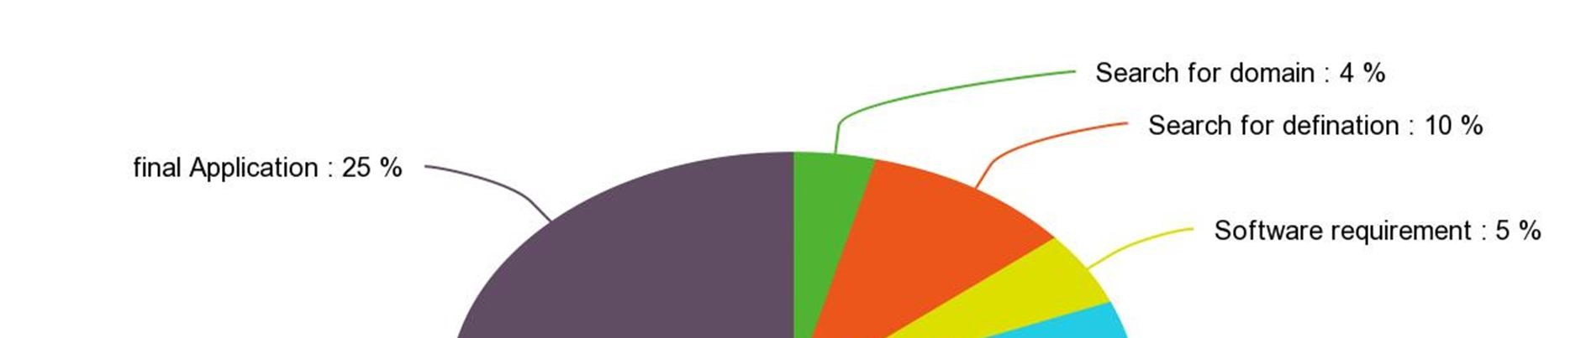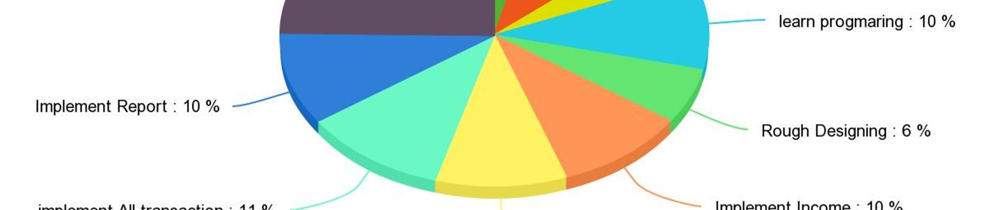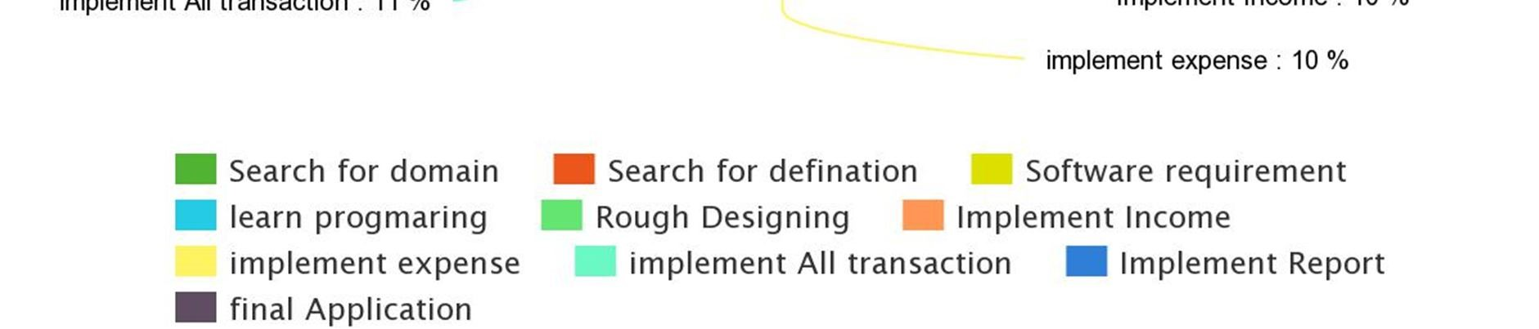

Figure 1.7 Work Plan

**CHAPTER 2: DESIGN**

**2.1 ANALYSIS**

Project Development approach and justification

Iterative Water fall Model

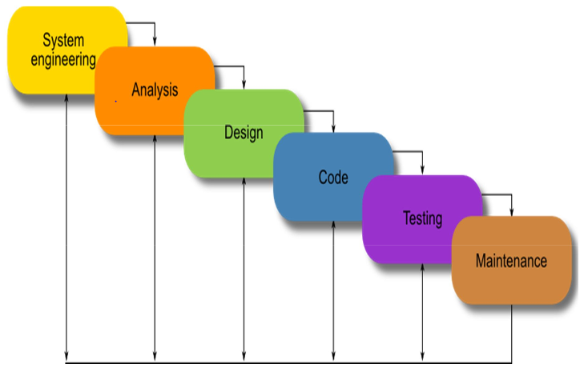

Figure 2.1 Software model

**2.1.1PROJECT PLAN**

1. Gather the module definition.
2. Checking the time schedule feasibility.
3. Requirement gathering for module.
4. Analysis on gathered requirement.
5. Designing.
6. Coding.
7. Testing.
8. Management

**2.2 DESIGN METHODOLOGY**

2.2.1 CLASS DIAGRAM:

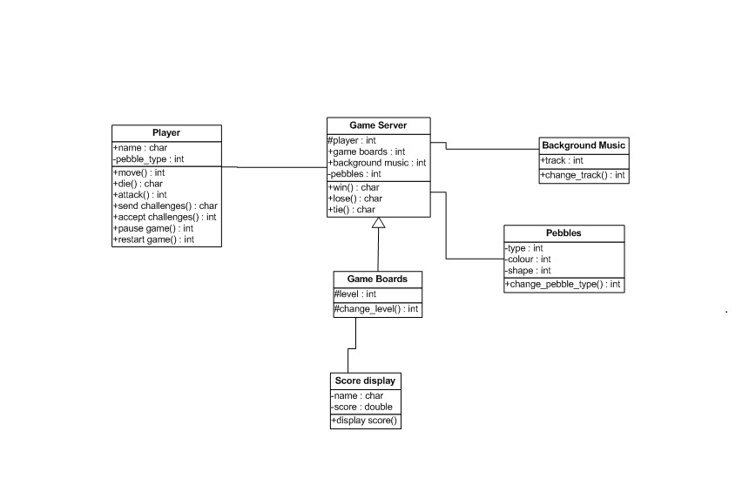

Figure 2.2.1 Class Diagram

2.2.2 USECASE DIAGRAM:

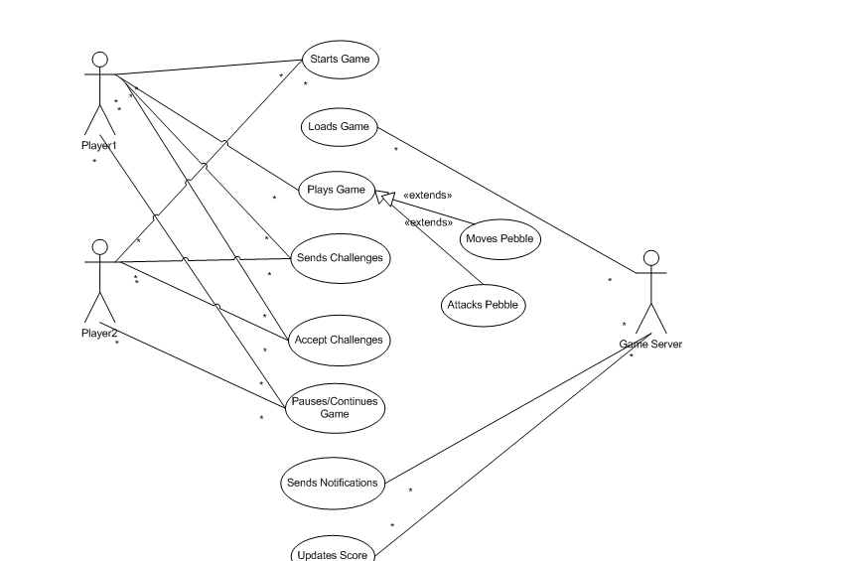

Figure 2.2.2 Usecase Diagram

2.2.3 SEQUENCE DIAGRAM:

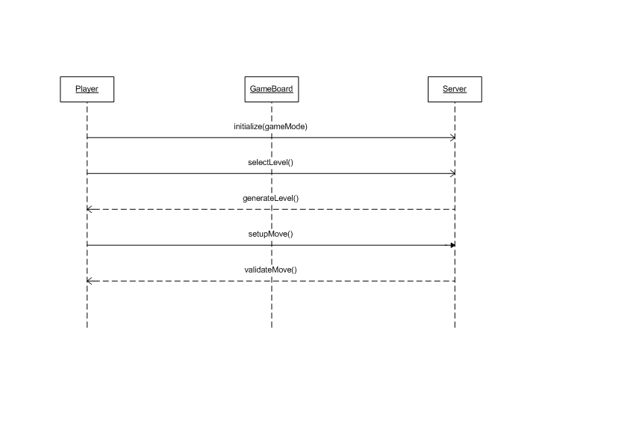

Figure 2.2.3 Sequence Diagram

**2.3 IMPLEMENTATION STRATEGY**

**2.3.1 Implementation environment**

(1)Cocos2d-X

(2)Turbo C++

(3)MYSQL Database

(4)Microsoft Visio 2007 for UML diagrams & Database Designs

**2.3.2 Coding Standards**

(1)Extension of cocos file is .sln.

(2)Extension of android application is .apk.

**2.3.3 Security Features**

No need of any security to play the game.

Anyone can enjoy the game without any threat of security breach.

**2.4 CANVAS**

**2.4.1 Empathy Summary**

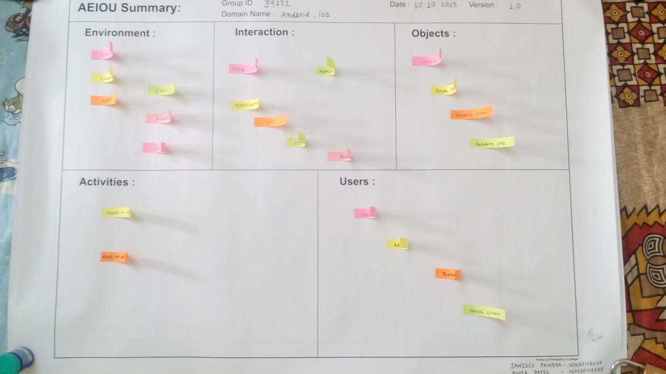

Figure 2.4.1 Empathy Summary

**Input through AEIOU Framework:**

-Alert to send moves to other users.

-Alert to send resume game.

**Scouted Challenges:**

-Getting your game noticed

-Adding AI in our game.

-Increase difficulty level.

-OS fragmentation.

-Fickle Users

-Creating game boards for different levels.

-Maintaining minimum storage space for game.

-Maintaining Score-Boards.

**Top 5 Problems:**

(1)Adding AI in our game.

(2)Increase difficulty level.

(3)OS Fragmentation.

(4)Creating game boards for different levels.

(5)Maintaining minimum storage space.

**Exact Problem from 5 Possibilities:**

-To increase the complexity of our game as the game level increases.

**2.4.2 AEIOU Summary:**



Figure 2.4.2 AEIOU Summary

**Environment:**

-Internet

-Electricity

-GSM

-C++

-Android

**Interaction:**

Interaction in our game is between:

~Player-Player

~Admin-Player

Output of our interaction is:

-Notifications

-SMS

-Moves

-Scores

**Objects:**

Objects in our game is:

-Mobile

-Player Database

-Email

-SMS

**Activities:**

-Alerts to send moves to other users.

-Alerts to resume game.

**Users:**

The users of our game is:

-Children

-Adults

-Teenagers

**-**Senior Citizens

**2.4.3 Ideation Canvas:**

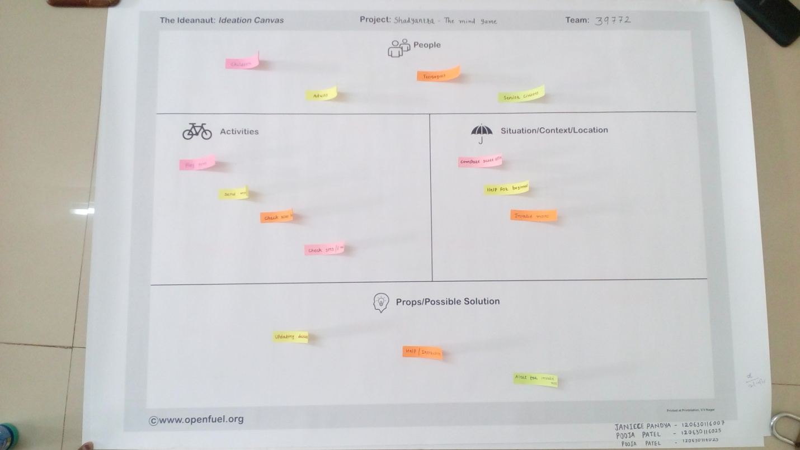

Figure 2.4.3 Ideation Canvas

**People:**

-Children

-Adults

-Teenagers

**-**Senior Citizens

**Activities:**

-Play Game.

-Send games.

-Check score boards.

-Check SMS/E-mail.

**Situation/Context/Location:**

-Scores can be compared offline.

-Help guide for beginners.

-Invalid Moves.

**Props/Possible Solution:**

-Updating database timely.

-Help/Instructions.

-Alert for invalid moves.

**2.4.4 Product Development Canvas:**

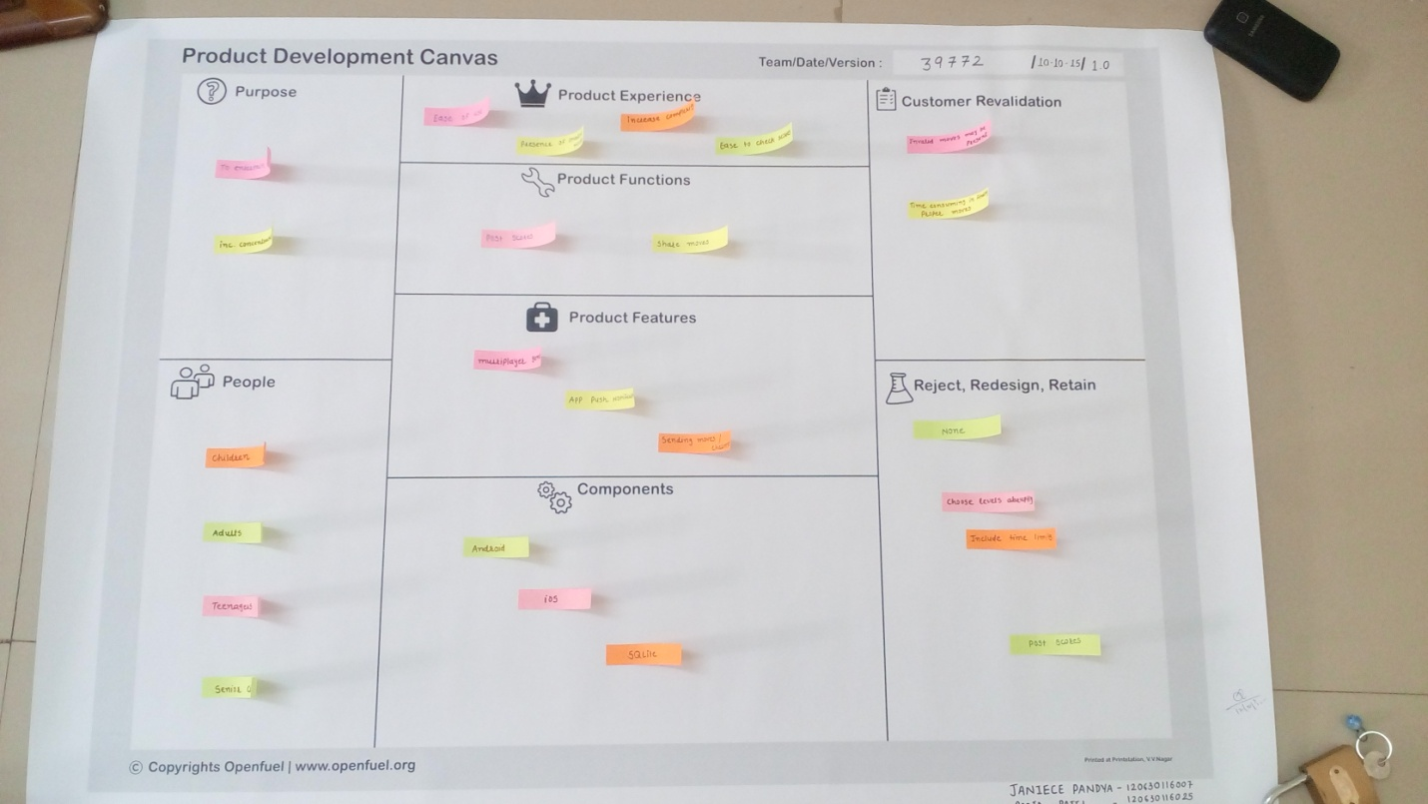

Figure 2.4.4 Product Development Canvas

**Purpose:**

The purpose behind our project is:

-To entertain people.

-To increase the concentration level.

**People:**

-Children.

-Teenagers.

-Adults.

-Senior Citizens.

**Product Experience:**

-Ease of use.

-Presence of invalid moves.

-Level wise increase in complexity.

-Ease to check scores.

**Product Function:**

-Post scores on scoreboards.

-Share moves.

**Product Features:**

-Multiplayer game.

-App push notifications.

-Sending moves/challenges to other users.

**Customer Revalidation:**

-Invalid moves may be present.

-Time consuming in finding proper moves.

**Components:**

-Android

-iOS

-MYsql

**Reject**

-None

**Redesign:**

-Choose levels abruptly.

-Include time limits.

**Retain:**

-Post Scores.

**2.5 BMC MODEL CANVAS**

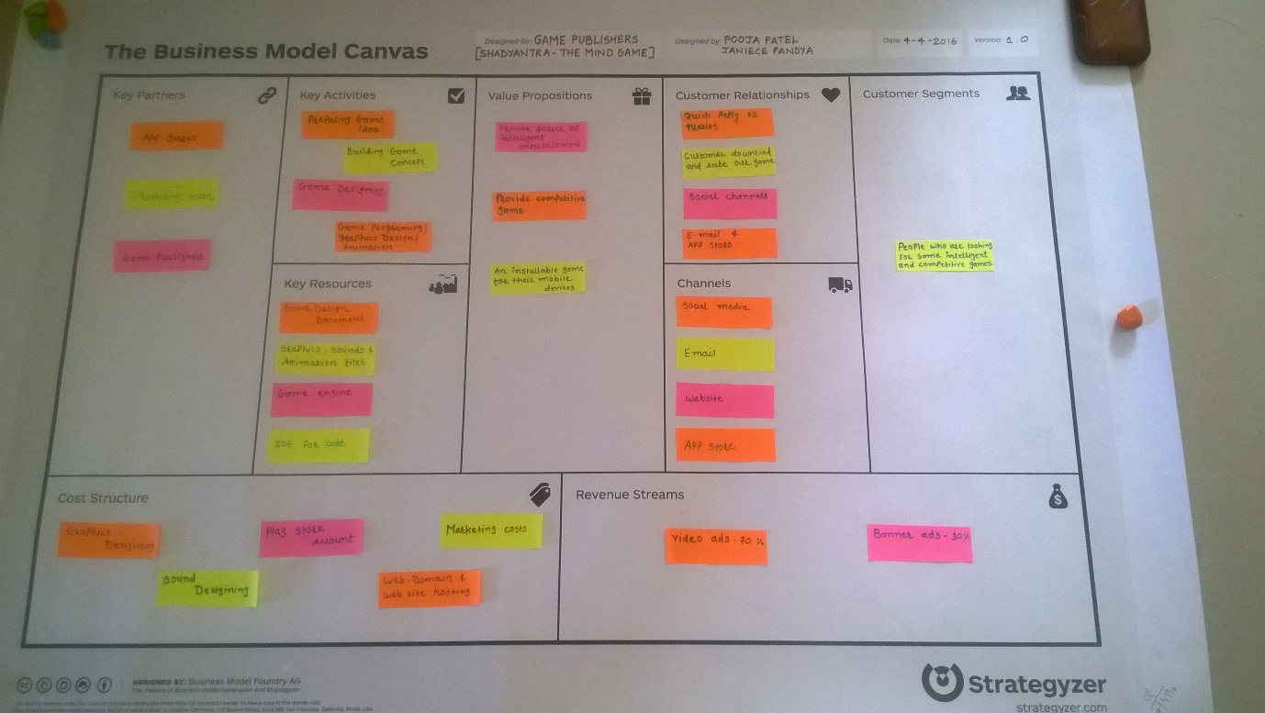

**2.5.1 KEY PARTNERS**

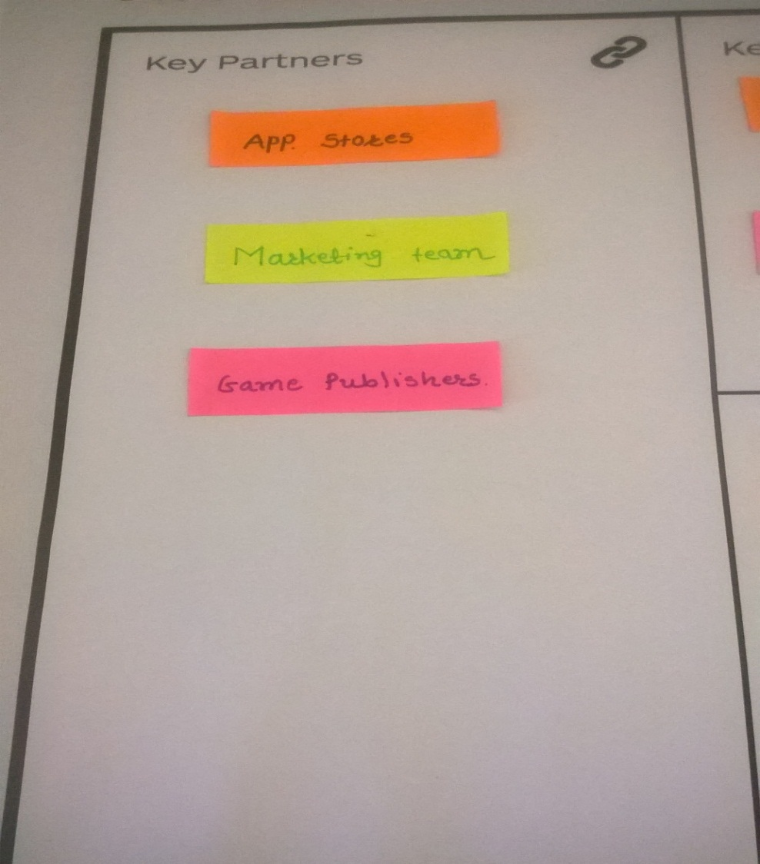

* **App Stores**
* **Marketing Team**
* **Game Publishers**

**2.5.2 KEY ACTIVITIES**

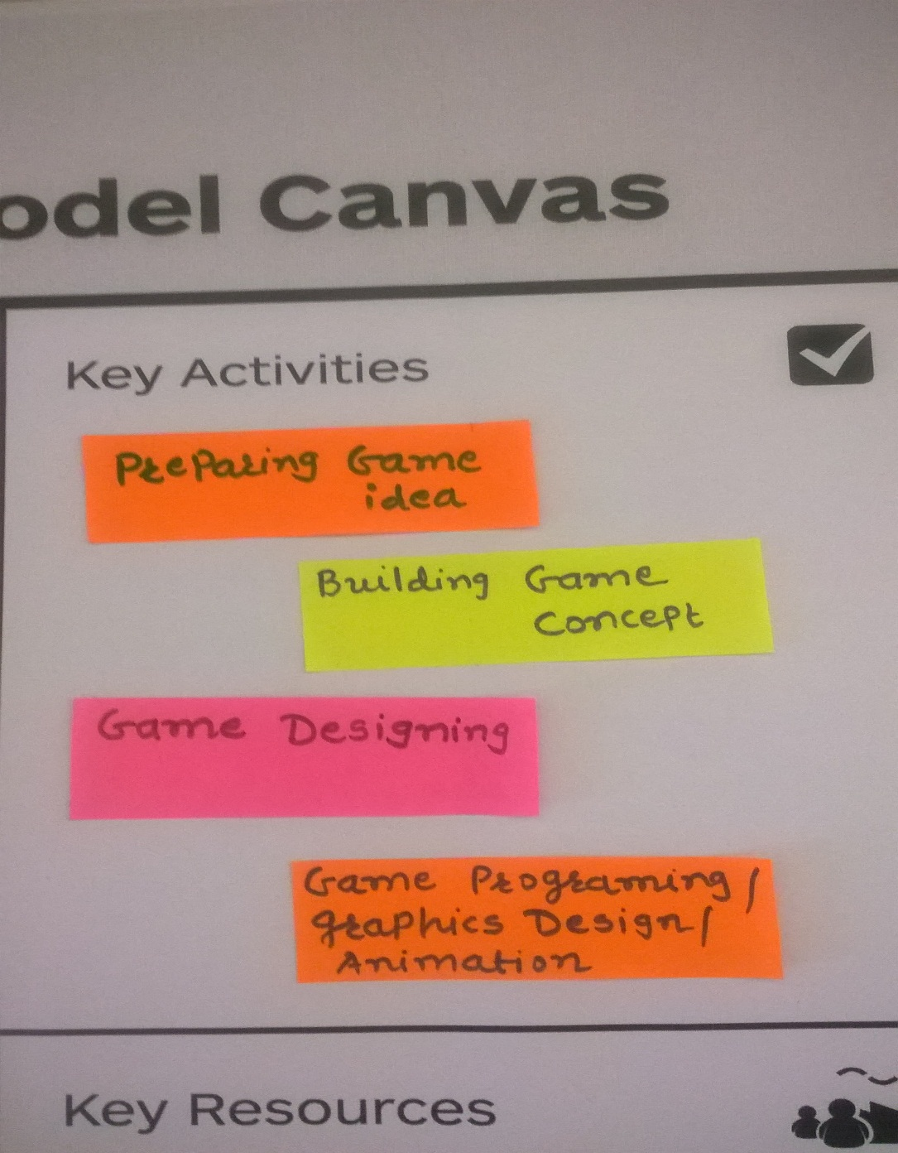

* **Preparing Game Idea**
* **Building Game Concept**
* **Game Designing**
* **Game Programming**

**2.5.3 KEY RESOURCES**

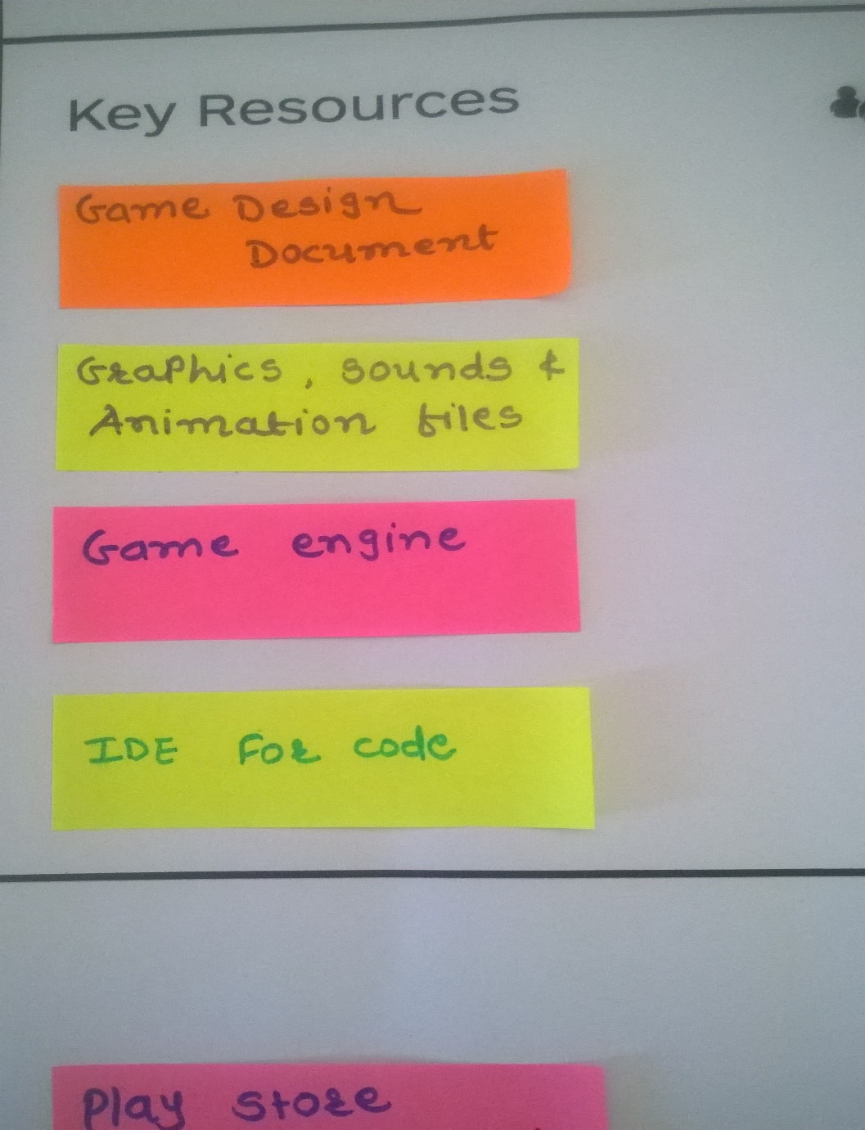

* **Game Design Document**
* **Graphics,Sounds & Animation Files**
* **Game Engine**
* **IDE for code**

**2.5.4 VALUE PROPOSITIONS**

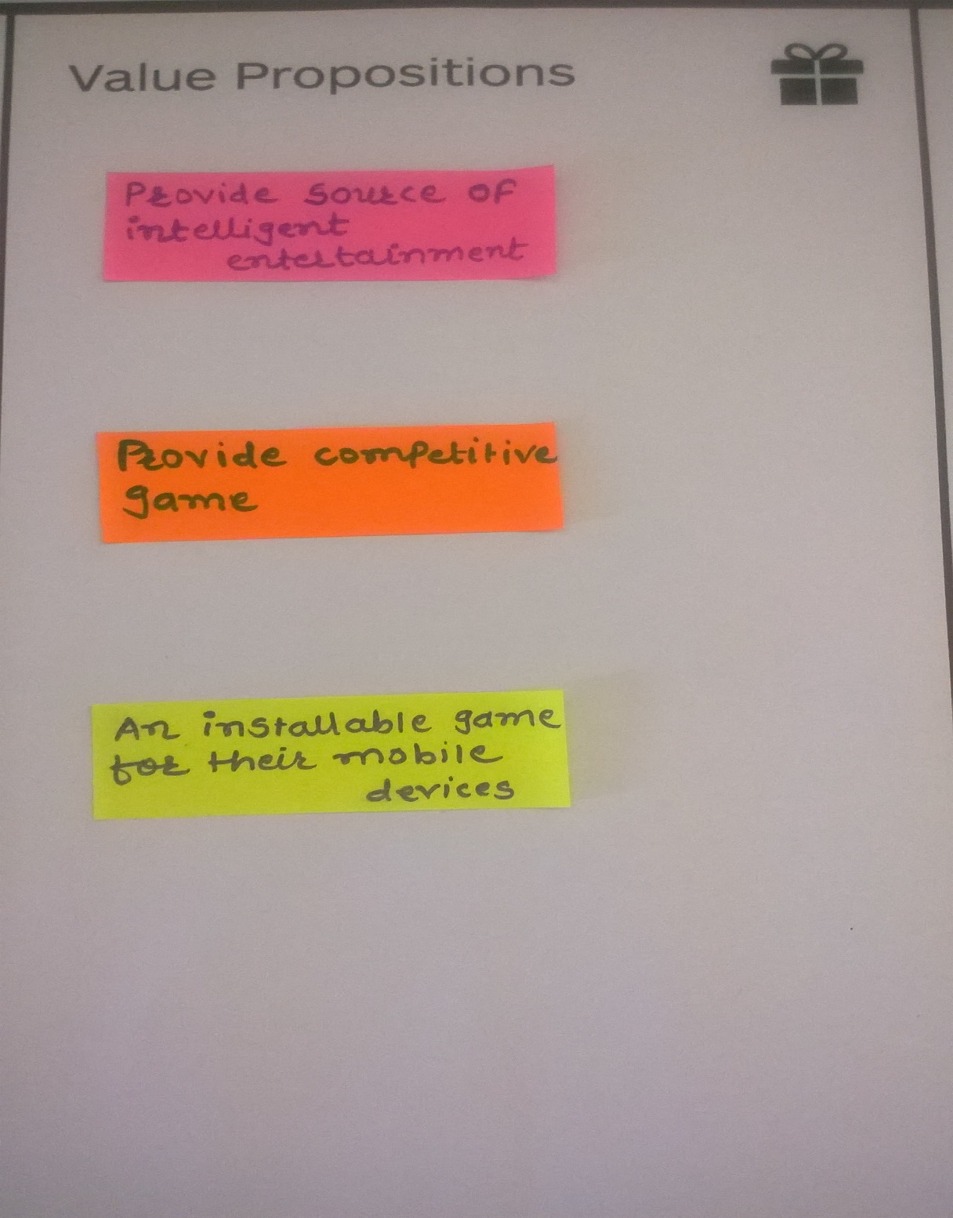

* **Provide source for Intelligent entertainment**
* **Provide Competitive game**
* **An installable game for their mobile devices**

**2.5.5 CUSTOMER RELATIONSHIPS**

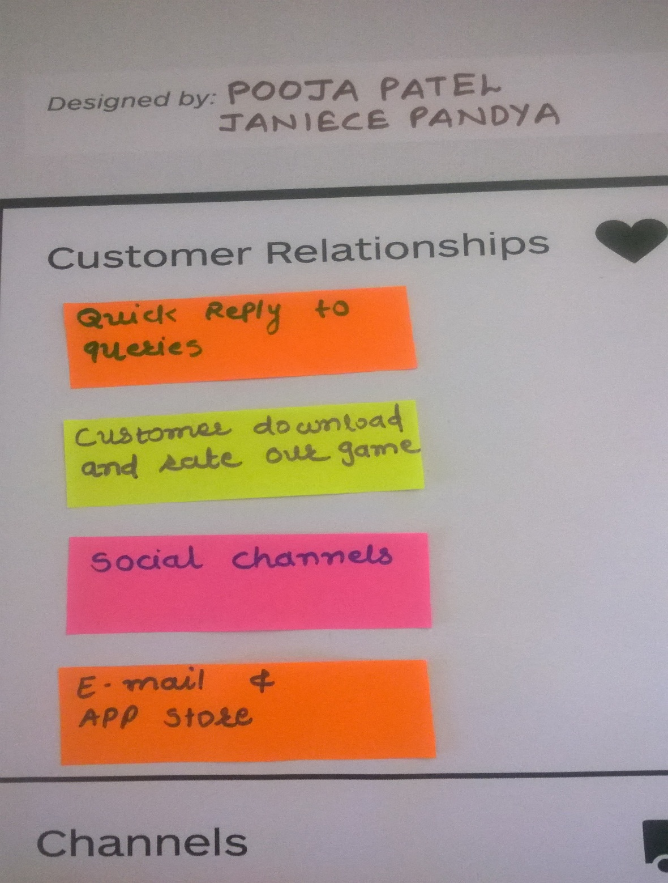

* **Quick reply to Queries**
* **Customer downloads & rates our game**
* **Social Channels**
* **E-mail & App Store**

**2.5.6 CUSTOMER SEGMENTS**

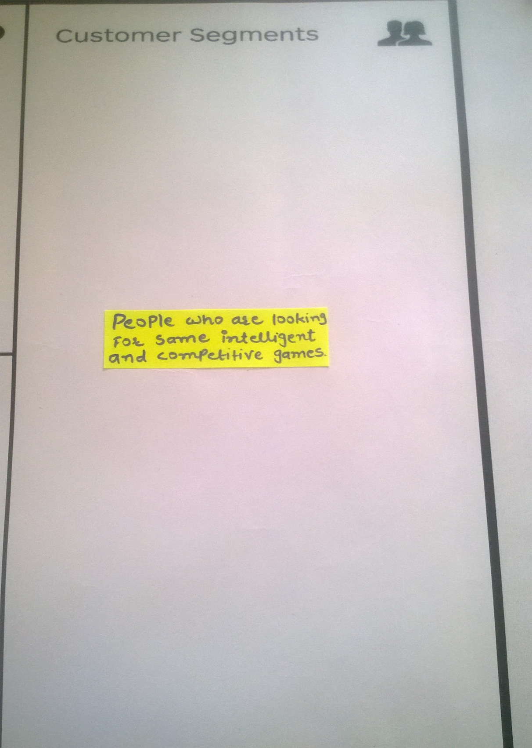

* **People who are looking for some intelligent and competitive games.**

**2.5.7 CHANNELS**

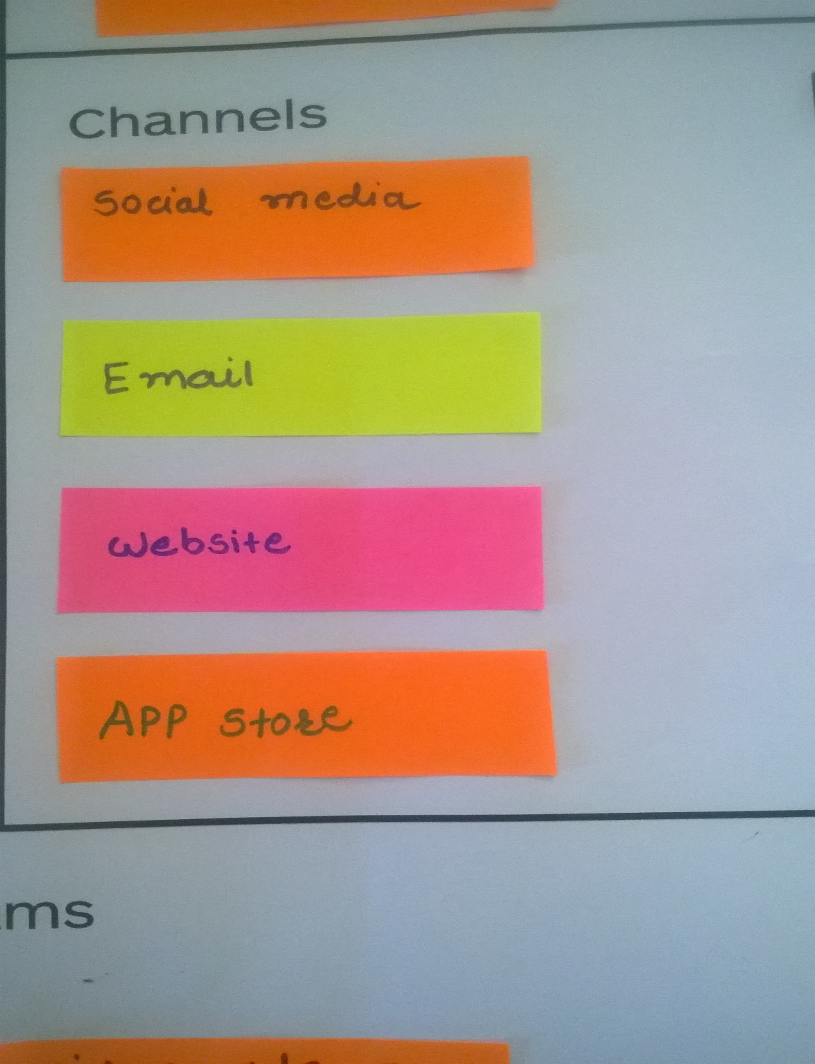

* **Social Media**
* **E-Mail**
* **Website**
* **App-Store**

**2.5.8 COST STRUCTURE**

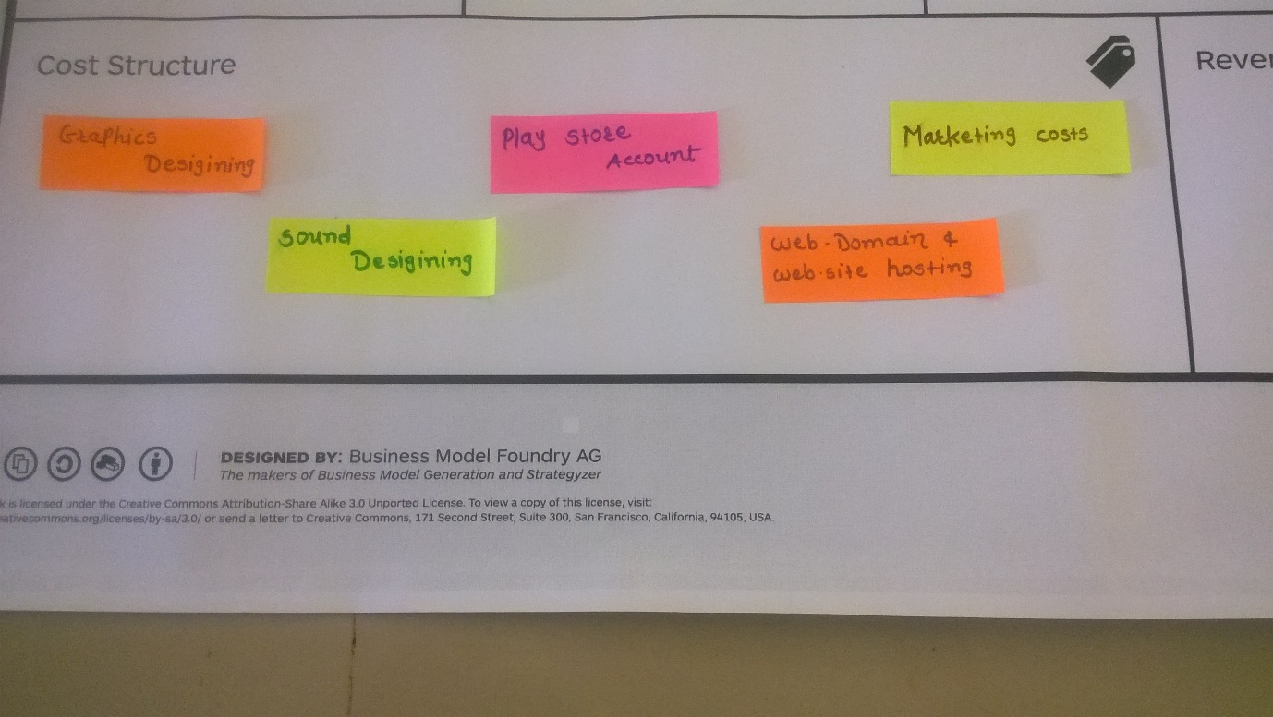

* **Graphics Designing**
* **Sound Designing**
* **Play Store Account**
* **Web-Domain & Web-site Hosting**
* **Marketing Cost**

**2.5.9 REVENUE STREAMS**

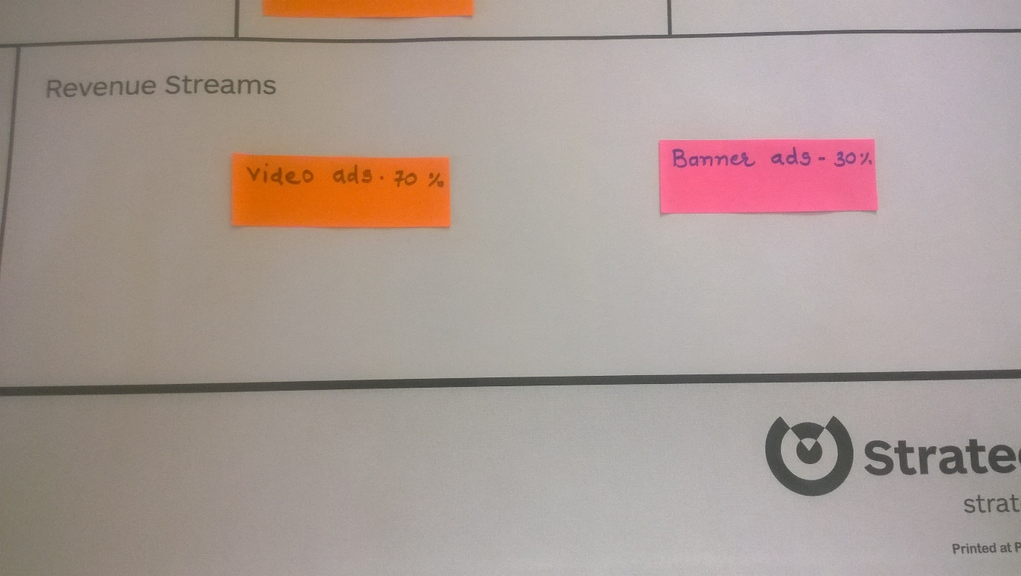

**Figure**

* **Video Ads-70%**
* **Banner Ads-30%**

**CHAPTER 3: IMPLEMENTATION**

**3.1 GAME HOME PAGE**

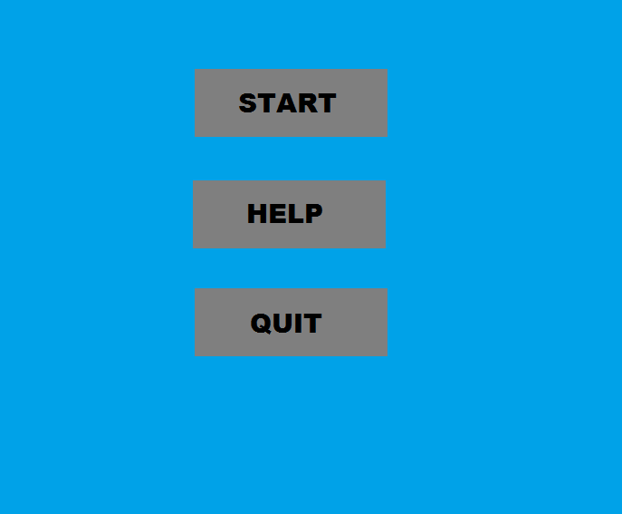

Figure 3.1 Game Home Page

**3.2 3x3 Level1**

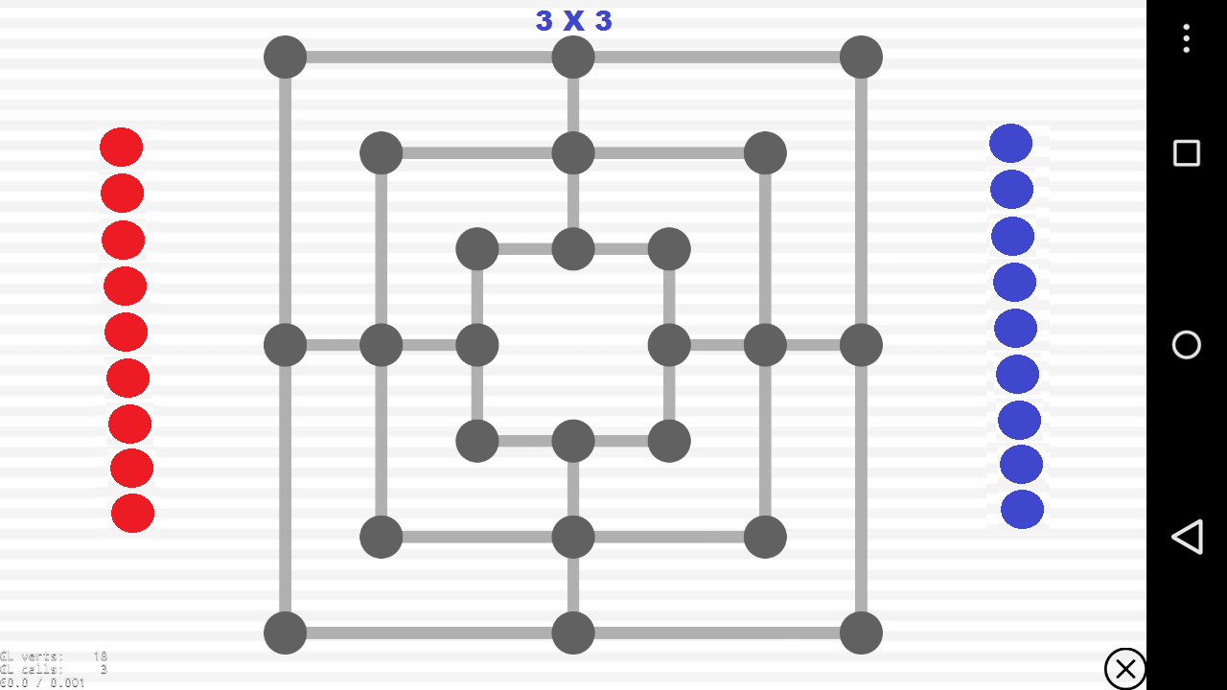

Figure 3.2 3x3 Level1

**3.3 3x3 Level2**

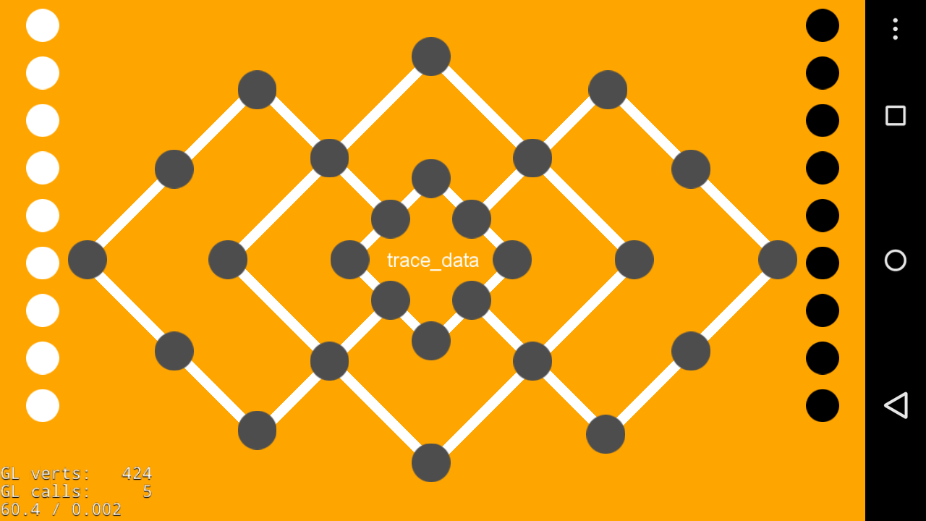

**3.4 Creation of a Mill**

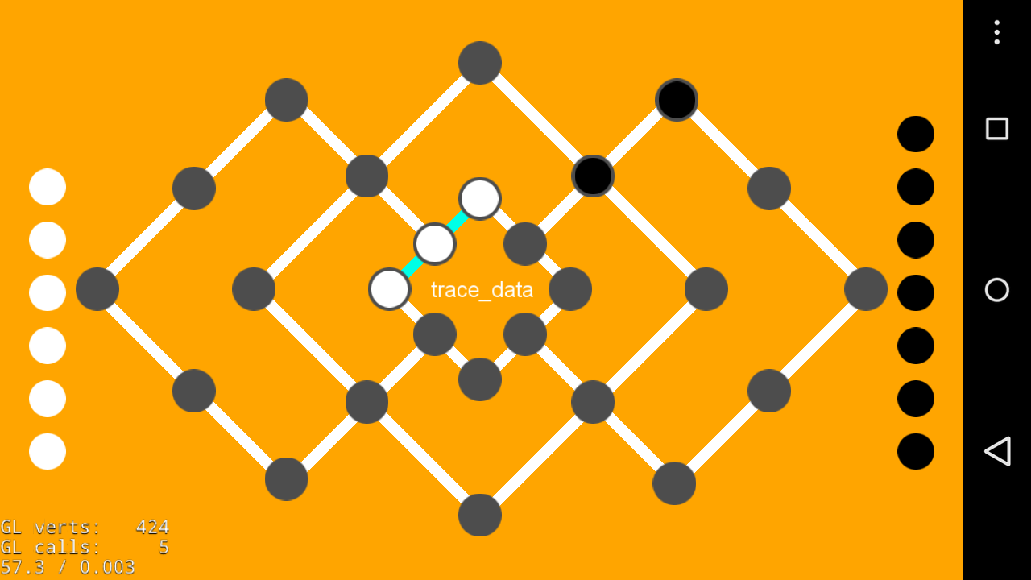

**3.5 4x4 Level**

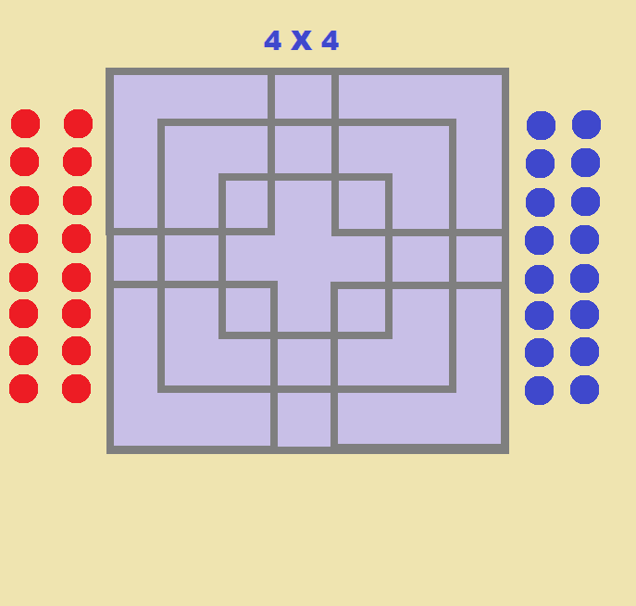

**3.6 5x5 Level**

: 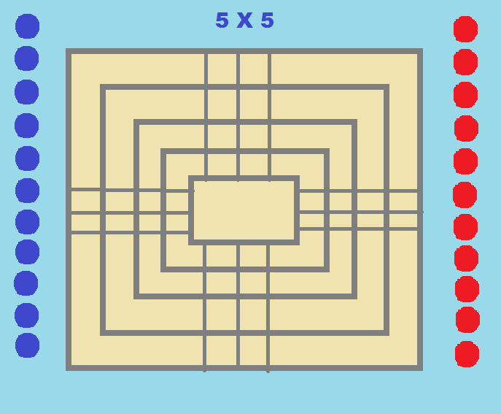

Figure 3.5.2 Theme 2

(Here we can change our theme to Theme 2.)

**CHAPTER 4: SUMMARY**

**4.1 CONCLUSION**

We have always been more attracted to Game Development field than any other field as a student of I.T. Engineering. We learnt about how to apply all the concepts of programming, that we have learned as a part of our curriculum. We came to know how different things are, when we actually implement them, from what we learn in theory. So, as a whole, we are quite happy to be gaining some practical experience in this field and we consider ourselves lucky to be able to get such guidance in this field, which is not so acknowledged in Gujarat.

There are several benefits for the user playing this game:

􀂗 Users will be spending time for this game and it will be good quality fun.

􀂗 Solving all the levels of varying complexity will help users develop their analytical and logical thinking capabilities.

􀂗 Learning to manage to solve the different levels on time will help user improve upon their Time Management capabilities.

􀂗 This game is not intended for any specific platform. Hence, it will be available to a wide range of devices.

**4.2 STUDY OF CURRENT SYSTEM**

The current Scenario in our system we have prepared the complete GUI of our game, designing of game boards and basic implementation of our game.

**4.3 ADVANTAGES**

-Increases concentration.

-Develops mind stratergies.

-Helps to develop time management.

-Develops logic.

**4.4 SCOPE OF FUTURE WORK**

We are going to implement this module in future:

4.4.1 Difficulty Levels in our game.

-More complex game boards.

4.4.2 Include time limit in our game.

-Players can challenge themselves to complete the game in given time limit.

4.4.3 Changing levels abruptly.

-Players can choose any levels without completing the previous level.

**REFERENCE**

**WEBSITES:**

1. [www.w3schools.com](http://www.w3schools.com)
2. [www.stackoverflow.com](http://www.stackoverflow.com)
3. www.cocos2d-x.org
4. [www.tutorialspoint.com](http://www.tutorialspoint.com)
5. www.wikipedia.com